# 001_PORT: Individual UI/UX Portfolio

Part 1

**User Goal: Ordering a product from Amazon for delivery.**

1. Sign-in

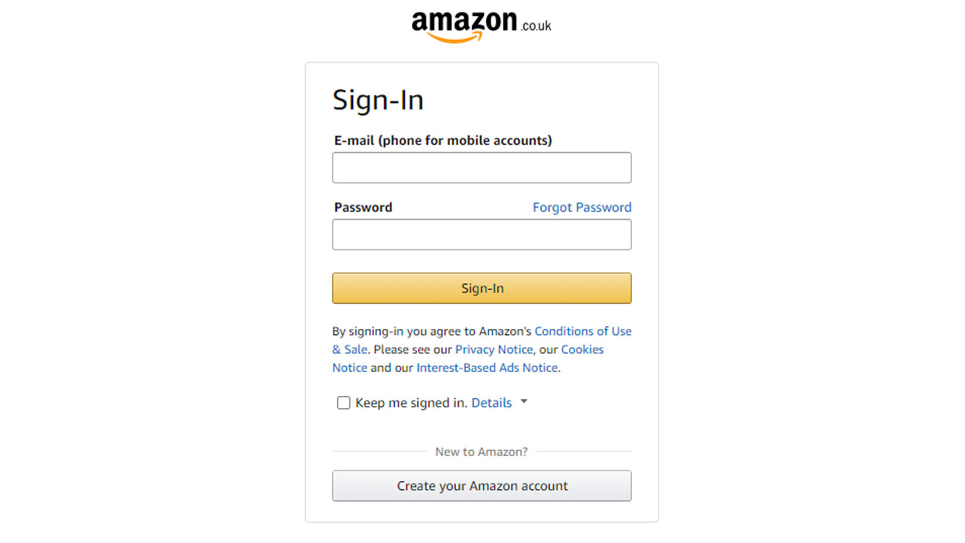

* Will the user be able to see the control for the action?

Positive – Two textboxes for the user to enter their login details are provided, with headings “email” and “password,” allowing the user to enter their data.

* Will the user recognise the control produces the desired effect?

Positive – It will be natural for the user to click on the sign-in button as it tells the user they will be able to “sign in” to their account.

* After the action is taken, will the user understand the feedback and be able to continue?

Positive – There is a clear loading animation in the middle of the screen that tells the user that the app is processing then disappears within a few seconds leading to the amazon homepage with a welcome message.

* Are there any problems that may occur?

Negative – If the user has slow internet connection, then the app will take longer to load.

Negative – If the user does not have internet connection, then they cannot login-in to their account and will be presented with an error message.

Positive – If the user types in the incorrect email, an error message appears in red text telling them that their email does not exist, and they are allowed to retype their email.

Positive – If the user has forgotten their password, they will be prompted with an error message and will be given the opportunity to change it by clicking on “forgot password.”

1. Search for product

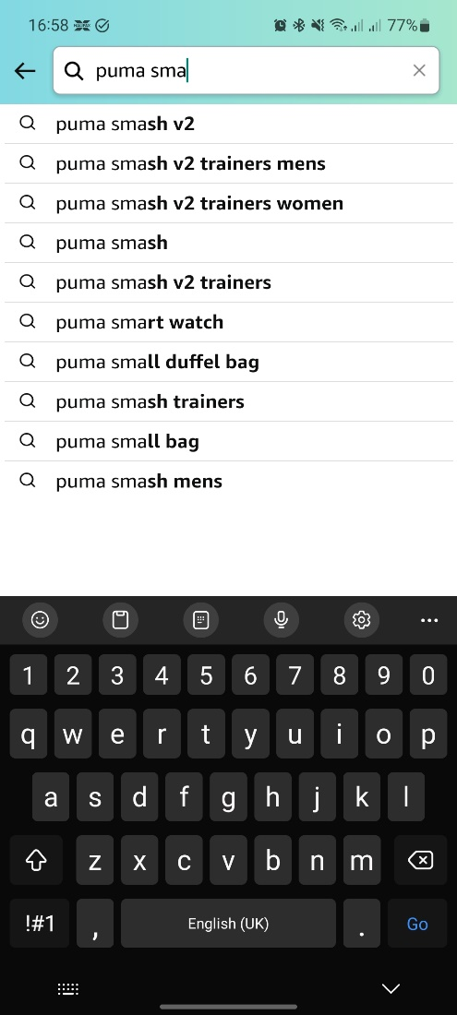

* Will the user be able to see the control for the action?

Positive – A textbox can be seen on top of the app with the text “search” accompanied by a search icon.

Positive – The search icon can be easily recognised by people of different languages, leading them to understand what the textbox is, if they do not understand English.

* Will the user recognise the control produces the desired effect?

Positive – The same textbox design used for the login details is used and this makes it natural for the user to click on the search textbox.

* After the action is taken, will the user understand the feedback and be able to continue?

Positive – A results page will be created showing all products related to the user's search with a “results” heading.

* Are there any problems that may occur?

Negative – The user may mistakenly click on the back arrow instead of “go” on their keyboard as it may be unfamiliar to them. This is because it looks like a forward or continue icon and this will take them back to the home screen. Text could have been added to it to make it more understandable.

1. Select product.

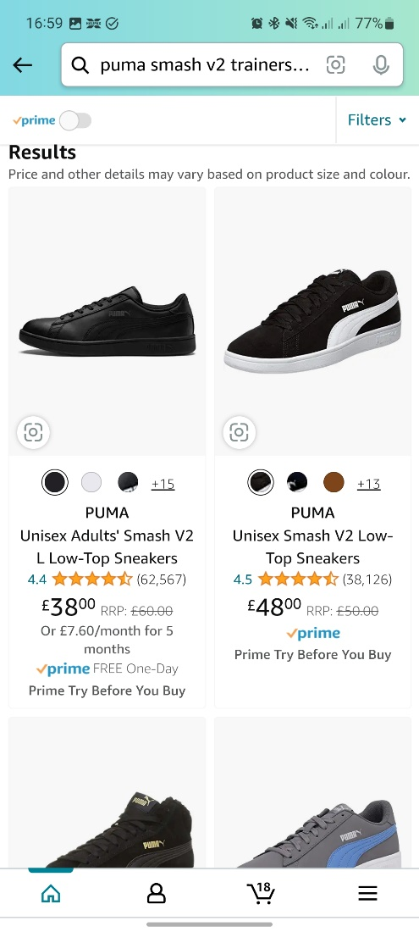

* Will the user be able to see the control for the action?

Positive – Products picture and description are put together to make it easy for the user to select the product they are looking for.

Negative – Too much information about each product is displayed on the page diminishing the user's visibility.

* Will the user recognise the control produces the desired effect?

Positive – The user will naturally click on what product they are interested in because they can be easily seen and differentiated, and the design of the products result page is consistent.

* After the action is taken, will the user understand the feedback and be able to continue?

Positive – Yes, there will be a quick change in state of the page after a negligible period and user will be directed to the item page.

* Are there any problems that may occur?

Negative – User may mistakenly click the camera icon to left of picture and will be led to a “more like this” page. The icon being portrayed as a camera confuses the users as a camera icon will be for a screenshot, view or zoom in action rather than leading to a “more like this page.” A “like this” text button could be used to help users better understand the interface design.

1. Select product options and buy.

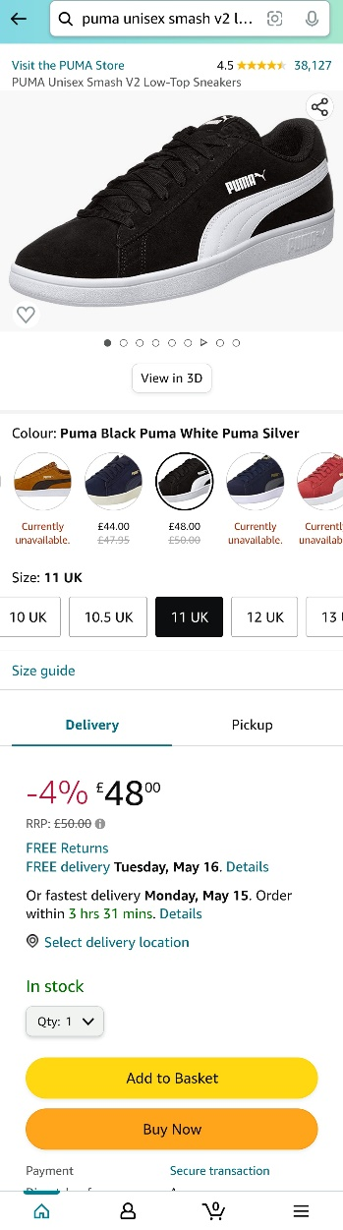

* Will the user be able to see the control for the action?

Positive – Users are presented with a page of the product’s pictures and details focusing on that specific product. Selected product can be easily recognised form its picture and tells the users that they have correctly selected the product they wanted.

Positive – Users are given different options to select from, such as colour, size, and delivery method, which has been well organised and describes or shows what will happen if the user were to click on it.

Negative – As there is too much information, different buttons and options on the screen, the user may become overwhelmed of what to do next.

* Will the user recognise the control produces the desired effect?

Positive - “Buy now” option clearly states the user’s primary goal which is to buy the product. This makes it natural for the user to click it as they have recognised their goal.

* After the action is taken, will the user understand the feedback and be able to continue?

Positive – Yes. There is a negligible pause time and users are then presented with a checkout page.

* Are there any problems that may occur?

Negative – User may click buy now without selecting the correct size, colour, and delivery method as there is no error message telling the user that they have not selected their preferences.

1. Pay and confirm.

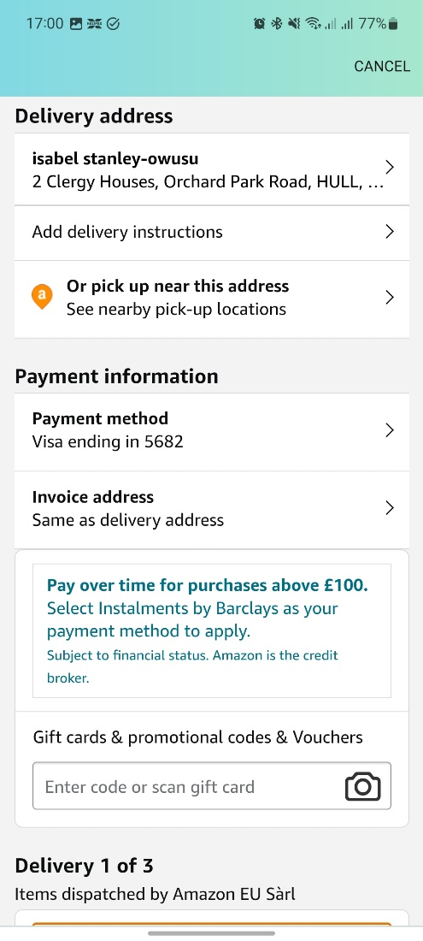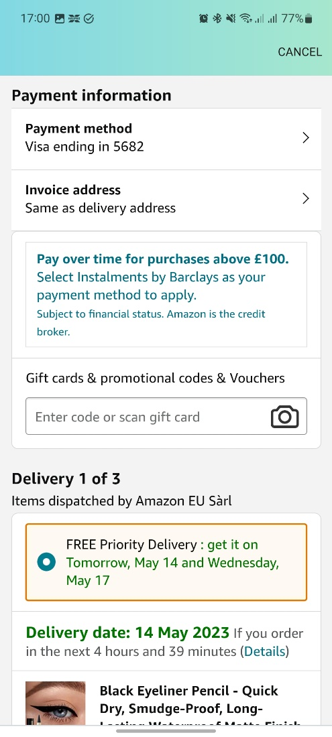

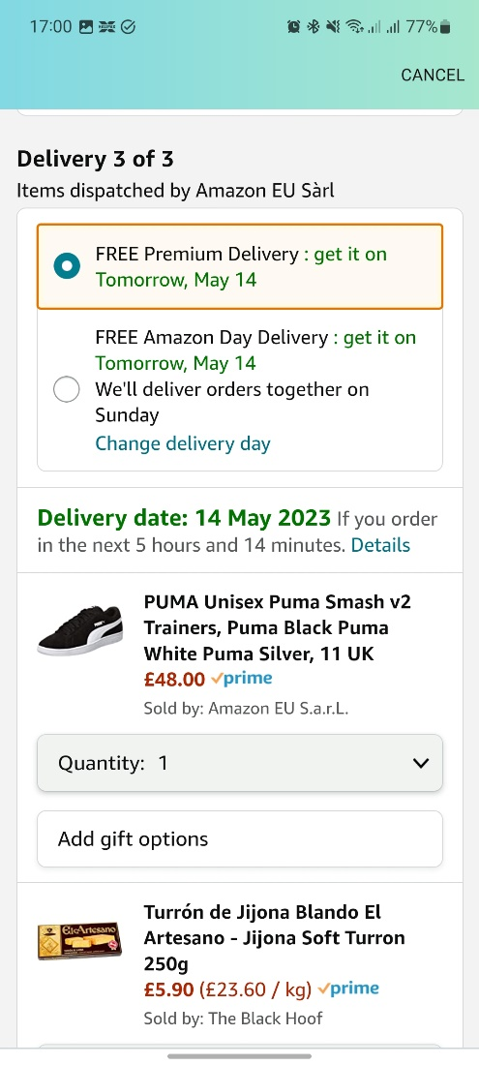

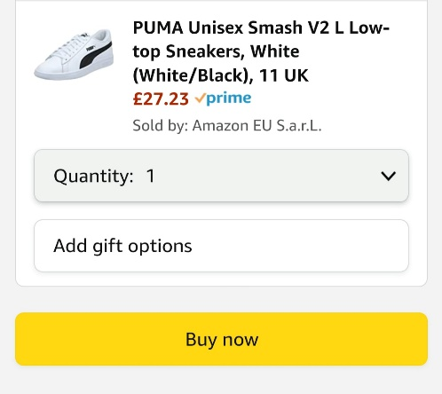

* Will the user be able to see the control for the action?

Negative – No, as there is too much information on the checkout page which diminishes the user's visibility.

Positive – Yes, as there are concise subheadings for every part the user needs to customize to buy the product and it does not have to be looked up.

* Will the user recognise the control produces the desired effect?

Positive – There is a buy now button at the end of the page which is concise and highlights the user's primary goal.

* After the action is taken, will the user understand the feedback and be able to continue?

Positive – A change of state occurs after a negligible pause, and the user is presented with an “order placed” page telling the user that they have confirmed the order.

* Are there any problems that may occur?

Positive – No, but user may end up wanting to cancel buying product and can easily do so by clicking on the cancel button. This gives user control and freedom and allows them to undo their actions when using the interface.

**User Goal: Creating a new playlist.**

1. Sign-in

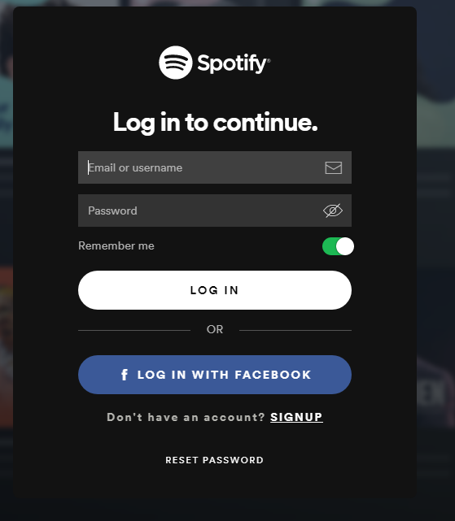

* Will the user be able to see the control for the action?

Positive – Two textboxes for the user to enter their login details are provided, with headings “email or username” and “password,” allowing the user to enter their data.

* Will the user recognise the control produces the desired effect?

Positive – It will be natural for the user to click on the login-in button as it tells the user they will be able to “login” to their account.

* After the action is taken, will the user understand the feedback and be able to continue?

Positive – There is a clear loading animation in the middle of the screen that tells the user that the app is processing then disappears within a few seconds leading to the Spotify homepage with a welcome message.

* Are there any problems that may occur?

Negative – If the user has slow internet connection, then the app will take longer to load.

Negative – If the user does not have internet connection, then they cannot login-in to their account and will be presented with an error message.

Positive – If the user types in the incorrect email or username, an error message appears in red text telling them that their email or username does not exist, and they are allowed to retype their email or username.

Positive – If the user has forgotten their password, they will be prompted with an error message and will be given the opportunity to change it by clicking on “reset password.”

1. Search for song

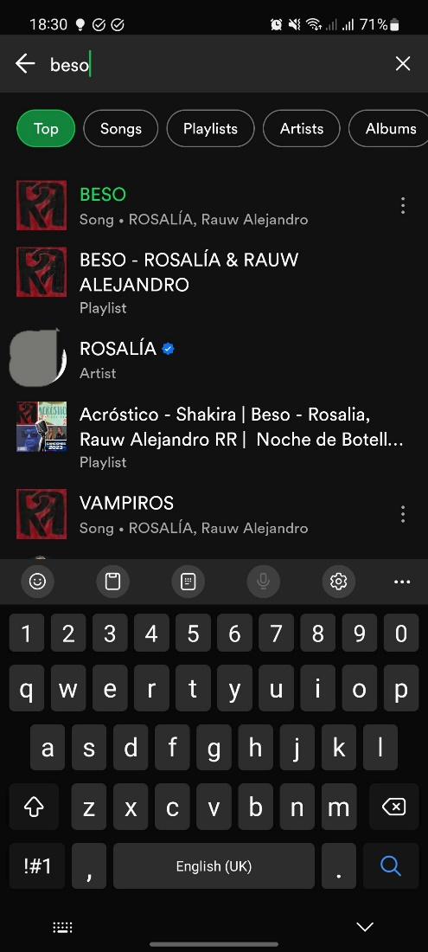

* Will the user be able to see the control for the action?

Positive – A textbox can be seen on top of the app with the text “search” accompanied by a search icon.

Positive – The search icon can be easily recognised by people of different languages, leading them to understand what the textbox is if they do not understand English.

* Will the user recognise the control produces the desired effect?

Positive – The same textbox design used for the login details is used and this makes it natural for the user to click on the search textbox.

* After the action is taken, will the user understand the feedback and be able to continue?

Positive – Results matching the entered data are displayed with the result that matches the closest to what the user typed as the first in the list. And as list goes down, how close the result is to what the user types decreases.

* Are there any problems that may occur?

Negative – The user may mistakenly click on the back arrow instead of “search” on their keyboard as it may be unfamiliar to them. This is because it looks like a forward or continue icon and this will take them back to the home screen.

1. Add to playlist.

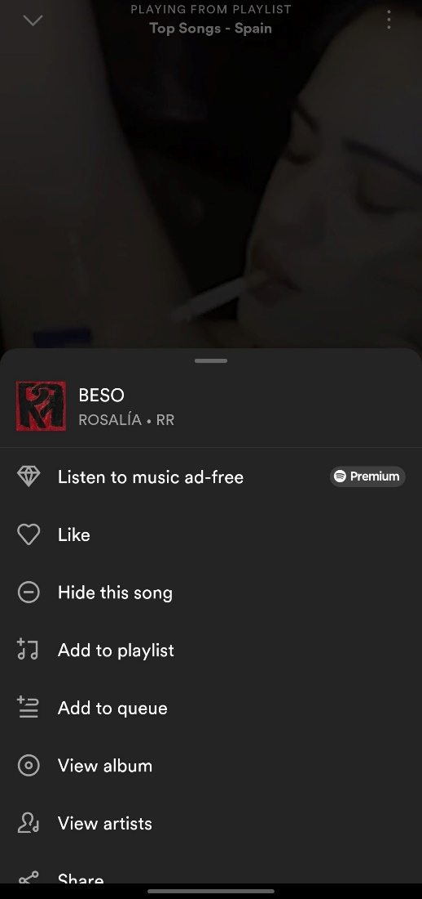

* Will the user be able to see the control for the action?

Positive – An option to “add to playlist” can be seen, accompanied by a plus music icon. This makes it easy for the user know how add to playlist as the user’s primary goal is made a clear option to pick.

* Will the user recognise the control produces the desired effect?

Positive - “Add to playlist” option clearly states the user’s primary goal which is to add to playlist. This makes it natural for the user to click it as they have recognised their goal.

* After the action is taken, will the user understand the feedback and be able to continue?

Positive – A change of state occurs after a negligible pause, and the user is presented with a “give your playlist a name” page.

* Are there any problems that may occur?

Positive – No, because design of the interface is focused on essentials and options given are concise, making it easy for the user to add the song to their playlist.

1. Create playlist.

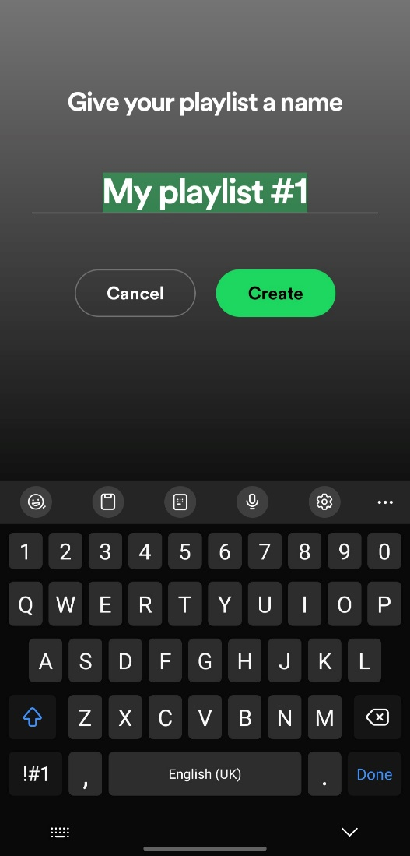

* Will the user be able to see the control for the action?

Positive – User is presented with the text “give your playlist a name which tells them the state of the interface.

Positive – Title of page is concise, and example of playlist name is given making it easy for an unfamiliar user to understand what they are supposed to do.

* Will the user recognise the control produces the desired effect?

Positive – After the user types in their name, the create button is visible below and will be naturally clicked on as it is highlighted and designed with a bright green background and clearly tells the user the action of the button as well as their primary goal. Also, in the real world, green stands for right/yes. For example, a traffic light goes green when it is right to move. This also makes it more likely for non-English readers to choose it as well.

* After the action is taken, will the user understand the feedback and be able to continue?

Positive – A popup message is presented to the user below the screen telling the user that the playlist has been created.

* Are there any problems that may occur?

Positive – No, but user may end up wanting to cancel creating the playlist and can easily do so by clicking on the cancel button. This gives user control and freedom and allows them to undo their actions when using the interface.

Part 2

**Heuristics/guidelines**

1. Home Automation App: <https://www.figma.com/file/hHg238spLetBTPA54UloDz/Home-Automation-App?type=design&t=F3ovGRWuubhM4GsW-1>

* No and yes buttons are used to turn off and on devices and this is used in every user interface in the real world. This makes it easy for the user to understand what the buttons do and highlights their primary goal of turning a device off or on.
* Icons for buttons make it easy for users to recognise what buttons do instead of having to recall information from reading only text to perform an action.
* Users can undo their actions as there are back buttons clearly stated with text, accompanied with an icon.
* Underneath energy efficiency on and off buttons, a warning message is supplied to warn users of the actions that will occur if they were to turn energy efficiency mode on. This makes them aware of the outcome of clicking that button and causes them to make the right decision.
* Home and add buttons are accompanied by text to make user understand what the buttons do and aid the user with their goal.
* Content and visual design of UI are focused on the essentials, therefore avoiding the diminishment of the user’s visibility and this helps getting to the primary goal more easier and time efficient.

1. Student Wellbeing System: <https://www.figma.com/file/SFdkmXTAjd73AOuEdFy74F/Student-Wellbeing-System?type=design&t=F3ovGRWuubhM4GsW-1>

* After user clicks on buttons there is always a brief pause, and they are presented with a new page with a title that tells the user what state they are in.
* Text used on designs are concise and this helps the user understand what page they are on as well as what the button they click on does. Without having to look up the words, it also makes getting to the user’s end goal easier and time efficient.
* Back buttons are supported with text so that when a user wants to exit a current interaction they can freely and naturally do so.
* Content and visual design of UI are focused on the essentials, therefore avoiding the diminishment of the user’s visibility and help getting to primary goal more easier and time efficient.

Part 3

**User Goal: Turn off energy efficiency and light 1 in the bedroom.**

1. This is the URL for the web publish of the teleport file: <https://home-automation-app-9u0lvb.teleporthq.app/>
2. I have added both lecturers to my git repository. Also, using GitHub in teleport didn’t work after many tries so I manually created the repository, and it contains files before applying fixes from tester and after
3. Image sequence of the goal execution flow in your implemented interface has been added to the zip folder.
4. Video for walkthrough of web app with different window sizes is in the zip folder.

**Brief Reflection**

Was able to add teleporthq as plugin to figma and select design for the user goal chosen. After importing the file, I had to replace the input textboxes so that users can enter their details before they login to their account. I also created an error page for each page. This is so that when the user performs the wrong action, they will be redirected to the page before the error is made and make a better decision to get to their primary goal. I also created new “on” pages and edited original pages of “on/off” pages so that I have an inactive on button page. When the user clicks on the on button then it changes to the on page. I also repositioned the design so that it is in the centre of the screen on every type of window size. Also, all the functions I had on figma had been removed so I had to recreate functions for clicking on the buttons.

Part 4

**User Goal: Turn on energy efficiency for whole house and light 1 in the bedroom.**

I decided to go with qualitative testing as it supplies in-depth analysis of the negatives and positives when using a user interface. It supplies details answers instead of yes and no or statistically based data. It is also faster to perform qualitative analysis and does not require a large group of people as compared to quantitative analysis.

**Reflection**

The design on the login screen is like what real-world websites have as their login pages and the textboxes and log in button have text that describe what is needed and what it does if you click on it. These make it easy to understand what to do. Text appearing when you type as well is common for all real-world login screens. The language was clear and login page was designed properly with a button allowing the user to get into their account. The energy efficiency button is not clear and does not seem like a button. Maybe change it to energy efficiency setting and make it look like the other buttons by adding an icon. Add and log out are positioned at the right place which make it easy for user to see. After clicking on the energy efficiency button, it loads instantly to the energy efficiency page. The page is clear, and the buttons are apparent and look like buttons. In energy efficiency, on and off look like buttons and tell you what they are going to do. After clicking the on button, it changes colour which supplies helpful feedback and shows it is active. After going back to home, and clicking on bedroom, user is instantly presented with the bedroom page. This shows the devices in the room, and well worded buttons and text. User sees heater button odd as it is different from all other buttons. Swapping the position of the text and the icon will make it like other buttons. Clicking on lighting button loads new page instantly with an easy-to-read page. Page separates two lights allowing user to select and control each light and has same format as other buttons. User wants hovering over buttons make showing an effect. After clicking on light 1 a new page loads up instantly and has same button format making everything clear. User finds it difficult to see difference between button and background as it only has a thin outline separating them. User suggests making buttons different colour to background to make it clearly seen. Button changes colour and shows it is active after clicking it. User also sees their light has turned on real life. Pretty easy to get to the end goal and Ui is remarkably simple with a minimalistic design following guidelines and principles. Error messages useful but will be better if there were more frames and it was used for errors users make not relating to inactive buttons.

**Two fixes**

Making buttons different colour to background to make it clearly seen.

Change energy efficient button text to energy efficiency settings and make it look like the other buttons by adding an icon.

Extra: Swapping the position of the text and the icon of heater button will make it like other buttons